# **CTF Topic: Zamar**



# **1. Introduction**

Converting images into documents typically involves using Optical Character Recognition (OCR) technology. OCR is a process where software analyzes the pixels of an image containing text and converts them into editable text characters that can be manipulated and saved in document formats like DOCX, PDF, or TXT.

# **2. Tools and requirements**

Zamar

# **3. Scenario**

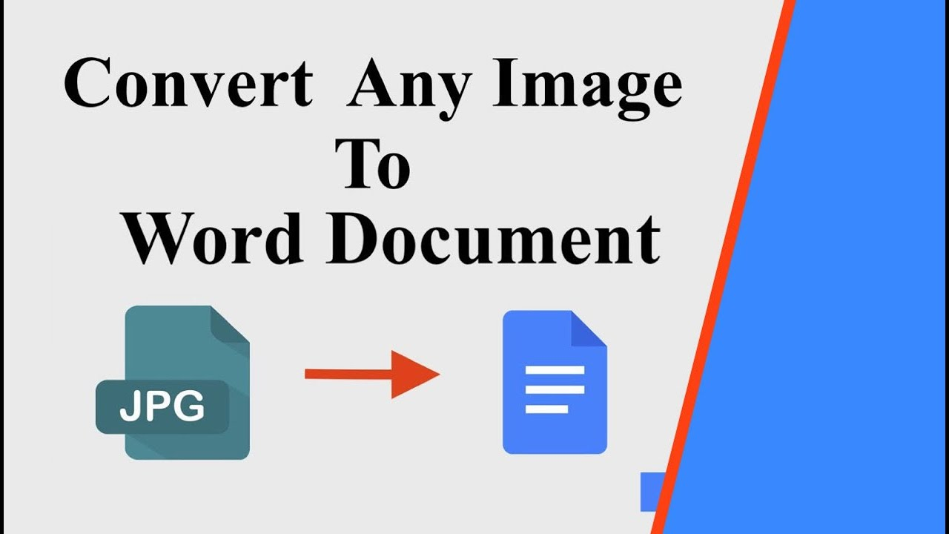

An institution named ING Skill is conducting a computer class. So a teacher is trying to convert images into docs.

# **4. Process to Follow while performing CTF**

Download the images.jpeg file from Link_1 and upload the file in the link_2

and in second. Download the file and open it.

Link_1: <https://www.mediafire.com/view/vga8benj6xtanpr/images.jpeg/file>

Link_2: <https://www.zamzar.com/>

# 

# 

# 

# **5. Let's Begin The Challenge**

# **Question**

Flag 1: What was the extension of the result in the images file?  
Answer: doc

Flag Captured.

Flag 2: Can You write inside the images?

Answer: Yes

Flag Captured.

Flag 3: Which color did it appear on the image?

Answer: Black

Flag Captured.

# **Hint**

